Name: Maloth Aditya

Roll No.: 120CS0124

Implement Uniform-cost-search and Iterative deepening depth first search algorithm

**Uniform cost search:**

**Code:**

# Uniform Cost Search Algorithm

def uniform_cost_search(goal, start):

    global graph,cost

    answer = []

    queue = [] #priority queue

    for i in range(len(goal)):

        answer.append(10**8)

    # insert the starting index

    queue.append([0, start])

    visited = {}

    count = 0

    while (len(queue) > 0):

        queue = sorted(queue)

        p = queue[-1]

        del queue[-1]

        # since maxHeap can be implemented by multiplying all values to -1 in minHeap

        p[0] *= -1

        if (p[1] in goal):

            index = goal.index(p[1])

            if (answer[index] == 10**8):

                count += 1

            if (answer[index] > p[0]):

                answer[index] = p[0]

            del queue[-1]

            queue = sorted(queue)

            if (count == len(goal)):

                return answer

        # check for the non visited nodes

        # which are adjacent to present node

        if (p[1] not in visited):

            for i in range(len(graph[p[1]])):

                queue.append( [(p[0] + cost[(p[1], graph[p[1]][i])])* -1, graph[p[1]][i]])

        visited[p[1]] = 1

    return answer

# main function

if __name__ == '__main__':

    # create the graph

    graph,cost = [[] for i in range(8)],{}

    graph[0].append(1)

    graph[0].append(3)

    graph[3].append(1)

    graph[3].append(6)

    graph[3].append(4)

    graph[1].append(6)

    graph[4].append(2)

    graph[4].append(5)

    graph[2].append(1)

    graph[5].append(2)

    graph[5].append(6)

    graph[6].append(4)

    # add the cost

    cost[(0, 1)] = 2

    cost[(0, 3)] = 5

    cost[(1, 6)] = 1

    cost[(3, 1)] = 5

    cost[(3, 6)] = 6

    cost[(3, 4)] = 2

    cost[(2, 1)] = 4

    cost[(4, 2)] = 4

    cost[(4, 5)] = 3

    cost[(5, 2)] = 6

    cost[(5, 6)] = 3

    cost[(6, 4)] = 7

    # goal state nodes

    goal = []

    # set the goal

    goal.append(6)

    # get the answer

    answer = uniform_cost_search(goal, 0)

    print("Minimum cost from 0 to 6 is = ",answer[0])

**OUTPUT**:

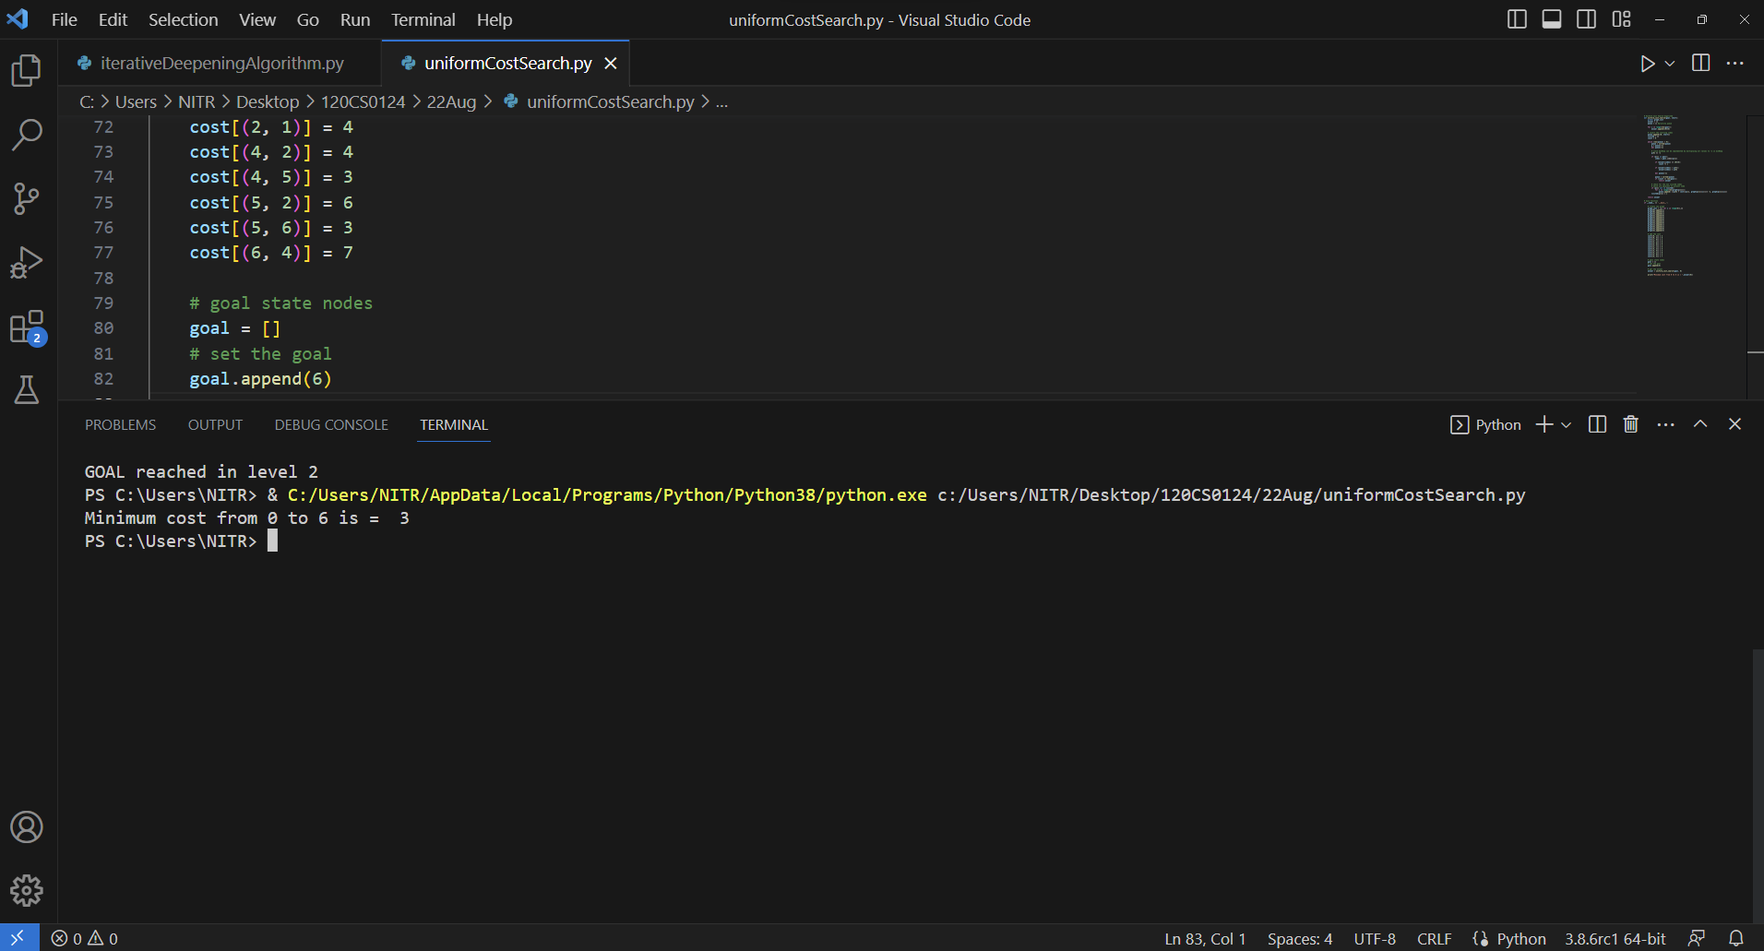

**Iterative Deepening Depth First Search:**

**Code**:

# Iterative Deepening Depth First Search Algorithm

global node

def dfs(src,target,maxDepth):

    print(f"{node[src]} ")

    if src == target : return True

    if maxDepth <= 0 : return False

    for i in graph[src]:

        if(dfs(i,target,maxDepth-1)):

            return True

    return False

# Create a graph

graph,node = [[] for i in range(8)],{}

#S A B C D E G  -> GOAL IS G

#0 1 2 3 4 5 6

graph[0].append(1)

graph[0].append(2)

graph[1].append(3)

graph[1].append(4)

graph[2].append(5)

graph[2].append(6)

node[0]='S'

node[1]='A'

node[2]='B'

node[3]='C'

node[4]='D'

node[5]='E'

node[6]='G'

target = 6; maxDepth = 4; src = 0

for i in range(maxDepth):

    if (dfs(src,target,i)):

        print(f"GOAL reached in level {i}")

        break

    else:

        print(f"GOAL not reachable in level {i}")

**OUTPUT:**

